6.1
clc;
clear;
close all;

% Signal generation
N = 1000;
t = (0:N-1)/N;

x = sin(2*pi*5*t);

% Quantizer parameters
bits = 3;
L = 2^bits;

xmin = -1;
xmax = 1;

% Quantization step size
delta = (xmax-xmin)/L;

% Uniform quantization
xq = delta * floor((x-xmin)/delta + 0.5) + xmin;

% Quantization error
e = x - xq;

% Error measurements
max_error = max(abs(e));
MSE = mean(e.^2);

% Display results
fprintf('Number of Quantization Levels = %d\n', L);
fprintf('Quantization Step Size = %.4f\n', delta);
fprintf('Maximum Quantization Error = %.6f\n', max_error);
fprintf('Mean Square Error = %.6f\n', MSE);

% Plot signals
figure;

subplot(3,1,1);
plot(t,x,'b');
grid on;
xlabel('Time');
ylabel('Amplitude');
title('Original Sinusoidal Signal');

subplot(3,1,2);
stairs(t,xq,'r');
grid on;
xlabel('Time');
ylabel('Amplitude');
title('Quantized Signal');

subplot(3,1,3);
plot(t,e,'k');
grid on;
xlabel('Time');
ylabel('Error');
title('Quantization Error');
output:
Number of Quantization Levels = 8
Quantization Step Size = 0.2500
Maximum Quantization Error = 0.124667
Mean Square Error = 0.004612
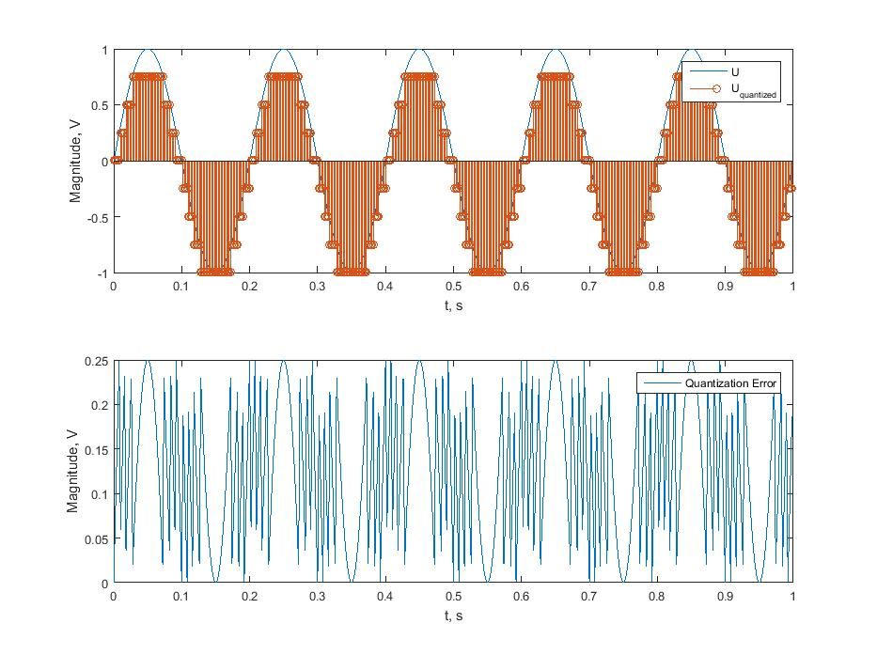
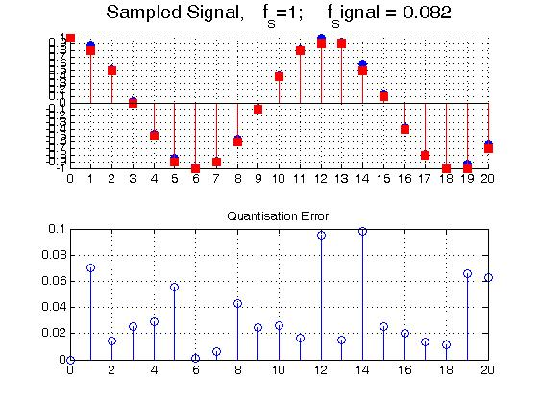
6.2
clc;
clear;
close all;

% Generate sinusoidal signal
x = 2*sin(2*pi*(0:999)/1000);

% Number of bits
bits = 4;

% Scaling factor
scale = 2^(bits-1);

% Truncation
x_trunc = floor(x*scale)/scale;

% Rounding
x_round = round(x*scale)/scale;

% Errors
e_trunc = x - x_trunc;
e_round = x - x_round;

% Mean Square Error
MSE_trunc = mean(e_trunc.^2);
MSE_round = mean(e_round.^2);

% Maximum errors
Max_trunc = max(abs(e_trunc));
Max_round = max(abs(e_round));

% Display results
fprintf('Number of Bits = %d\n',bits);

fprintf('Truncation MSE = %.6f\n',MSE_trunc);
fprintf('Rounding MSE = %.6f\n',MSE_round);

fprintf('Maximum Truncation Error = %.6f\n',Max_trunc);
fprintf('Maximum Rounding Error = %.6f\n',Max_round);

% Plot results
figure;

subplot(2,1,1);
plot(x,'b');
hold on;
plot(x_trunc,'r--');
grid on;
xlabel('Sample Index');
ylabel('Amplitude');
title('Finite Word Length Effect - Truncation');
legend('Original','Truncated');

subplot(2,1,2);
plot(x,'b');
hold on;
plot(x_round,'r--');
grid on;
xlabel('Sample Index');
ylabel('Amplitude');
title('Finite Word Length Effect - Rounding');
legend('Original','Rounded');
output:
Number of Bits = 4
Truncation MSE = 0.005300
Rounding MSE = 0.001227
Maximum Truncation Error = 0.124961
Maximum Rounding Error = 0.062178
